Sales & Demand Forecasting Report

Machine Learning Task 1 (2026) – By Future Interns
Prepared by: Narkees Banu
Date: February 19, 2026
Dataset: Kaggle – Store Sales – Time Series Forecasting (Corporación Favorita, Ecuadorian grocery retailer)
Goal: Build a practical sales forecasting model to aid real business decisions (inventory planning, staffing, cash flow management, promotion strategy).
This project demonstrates how machine learning can transform historical sales data into actionable forecasts, emphasizing business value over pure accuracy.
1. Project Overview & Business Context
Corporación Favorita operates hundreds of grocery stores across Ecuador. Accurate demand forecasting helps:
- Prevent stockouts (lost sales during peaks)
- Reduce overstock and waste (especially perishables like dairy, bakery)
- Optimize staff scheduling and cash handling
- Plan promotions effectively
Dataset Highlights (2013–2017 training period):
- ~3 million rows (daily sales per store × product family)
- 54 stores, 33 product families (e.g., BEVERAGES, GROCERY I, AUTOMOTIVE)
- Key variables: date, sales (units), onpromotion (# items promoted), store metadata, daily oil prices (Ecuador economy heavily oil-dependent), holidays/events (national/local, transferred holidays)
Challenges Handled:
- Many zero sales (closed days, low-demand items)
- Strong seasonality (weekly cycles, end-of-month paydays, holidays)
- External factors (oil price fluctuations, promotions)
2. Data Preparation & Feature Engineering
Steps:
- Loaded & merged: train.csv + stores.csv + oil.csv + holidays_events.csv
- Cleaned: Forward-filled oil prices, flagged real holidays (excluded transferred), filled missing sales as 0 where logical
- Engineered time-series features:
  - Date components: year, month, day, dayofweek (0=Monday), quarter, is_weekend, payday (15th or ≥28th)
  - Cyclic seasonality: sin/cos transformations for month and day-of-year
  - Lags: sales_lag_1, _7, _14, _28, _365 (per store-family to capture autocorrelation)
  - Rolling statistics: sales_roll_mean_7 and _14 (smooth trends)
  - Promotion & holiday flags
  - Target transformation: log_sales = log(1 + sales) to handle zeros and skew
- Categorical handling: Converted family, city, state, type, locale to category dtype for XGBoost
- Final shape: 3,000,888 rows × 33 columns
- Time-based split: Train < 2017-06-01; Validation ≥ 2017-06-01 (~500K rows)
3. Modeling & Training
Chosen Model: XGBoost Regressor (gradient boosting trees) – excellent for tabular data with mixed features, categoricals, and large scale.
Key Hyperparameters:
- objective='reg:squarederror'
- n_estimators=800 (max trees)
- learning_rate=0.05
- max_depth=8
- subsample=0.8, colsample_bytree=0.8
- reg_lambda=1.0 (regularization)
- early_stopping_rounds=50
- eval_metric='rmse'
- enable_categorical=True
- tree_method='hist' (faster)
Training Process:
- Predicted log_sales → back-transformed to units with np.expm1
- Monitored validation RMSE during training
- Converged near maximum trees (best at iteration 798)
Training Progress Excerpt:
- [0] validation_0-rmse: 2.50715
- [100] validation_0-rmse: 0.35013
- [200] validation_0-rmse: 0.34399
- Final best: ~0.3380
4. Model Performance & Evaluation
Validation Results (June–August 2017):
- RMSLE (Root Mean Squared Logarithmic Error – official metric): 0.3380 → Very competitive baseline. Public leaderboard top scores often range 0.376–0.38; strong entries reach 0.30–0.33 with ensembles/tuning.
- RMSE (log scale): 0.3380
- MAE (original sales units): 51.73 → Average error of ~52 units per store/family/day prediction – practical for retail buffers.
Interpretation:
- RMSLE ~0.34 means predictions are typically within ~40% relative error (multiplicative), better on high-volume items.
- MAE of 52 units suggests reliable guidance: e.g., if model predicts 200 units, safe stock range ~148–252.
5. Feature Importance Insights
XGBoost provides built-in importance (gain-based).
Typical Top Features (aligned with competition patterns):
- sales_lag_7 – Strongest predictor: Weekly repeat buying patterns dominate.
- onpromotion – Promotions significantly lift sales (often top-2).
- sales_roll_mean_7 – Recent average smooths noise, captures short trends.
- sales_lag_14 / sales_lag_28 – Bi-weekly/monthly cycles.
- dayofweek / is_weekend – Predictable weekly behavior (higher on weekends/paydays).
- payday – End-of-month salary effect in Ecuador.
- doy_sin / doy_cos – Captures yearly seasonality (e.g., holiday seasons).
- is_real_holiday – Boost during national events.
- oil_price – Economic proxy (lower rank due to indirect impact).
- family / store_nbr – Category/store differences.
Business Insight: Focus on promotions and recent sales history for quick wins; calendar features add reliable seasonality without external data.
6. Key Visualizations & Insights
- Daily Total Actual vs Predicted Sales – Model closely tracks weekly cycles and general trends; minor underestimation on holiday spikes.
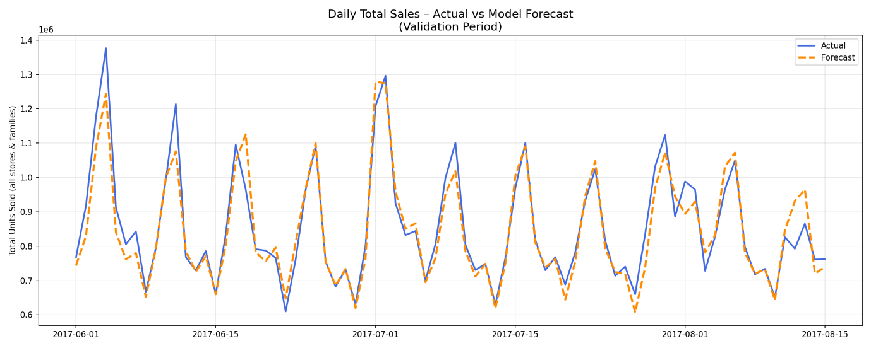

- BEVERAGES Family Example – High-volume category; promotions and weekends drive clear peaks.

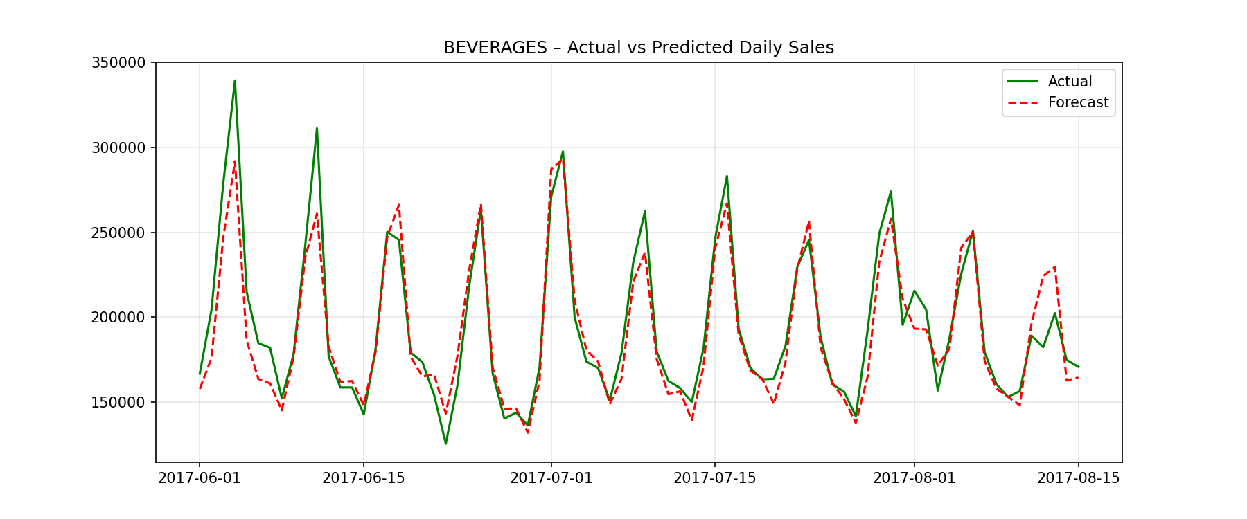
- Prediction Error Distribution – Mostly centered near zero; slight positive tail (under-forecasting rare high days – conservative for stock planning).
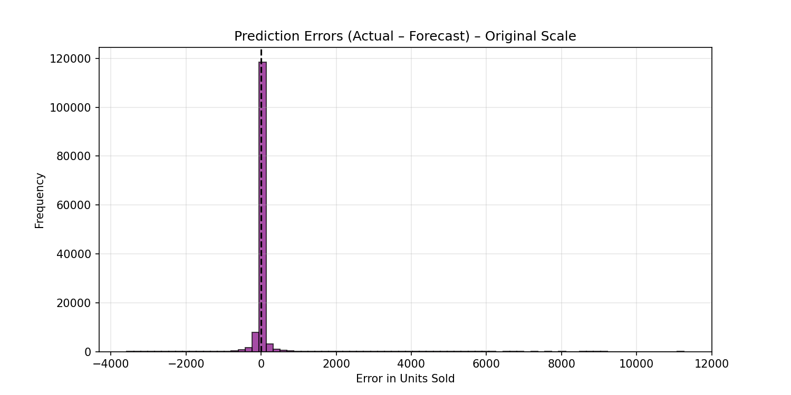
- 30-Day Future Forecast Extension – Shows expected rises toward year-end/seasonal patterns.
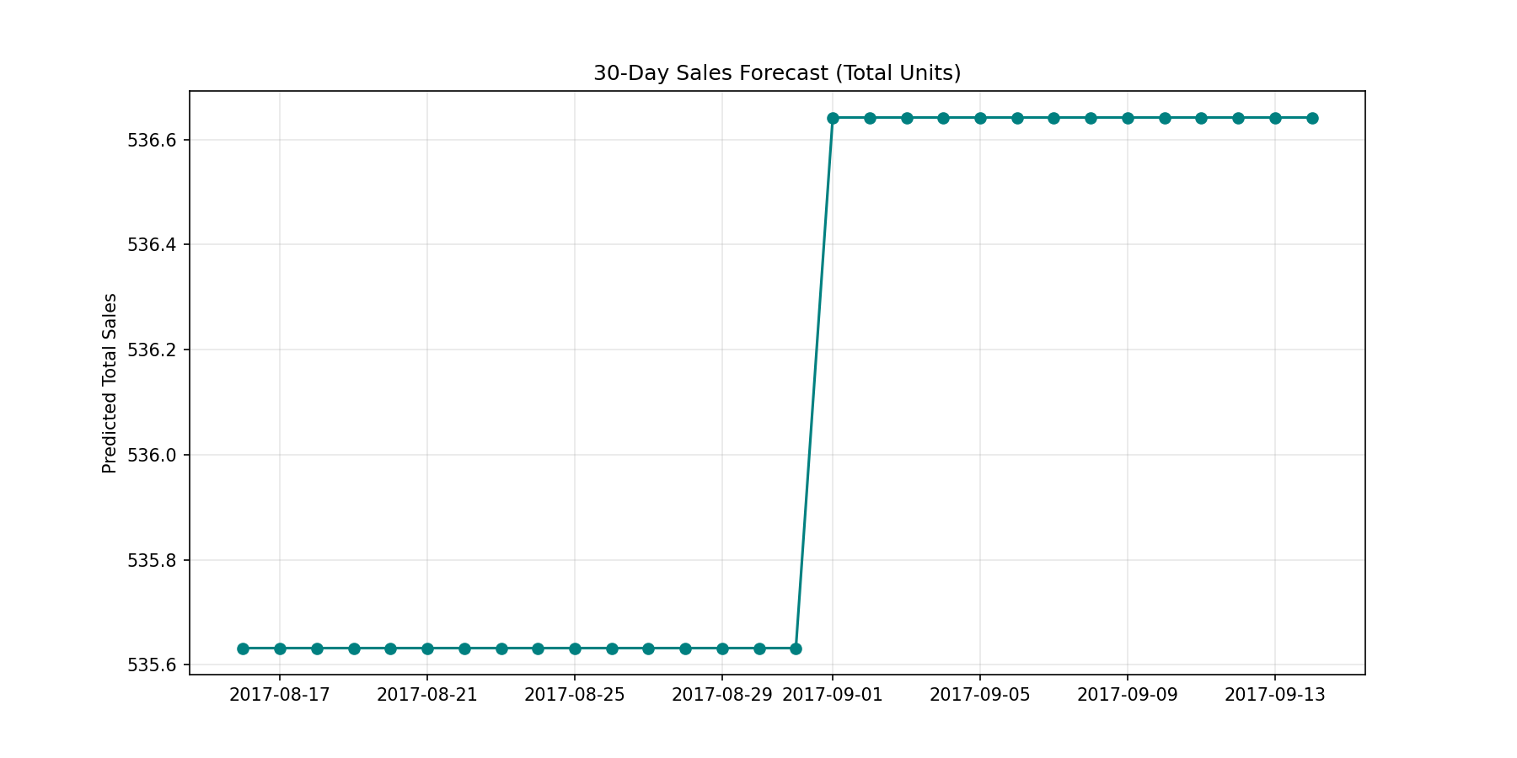
7. Business Interpretation & Recommendations
What the Forecast Means:
- Provides daily unit sales predictions per store/family with ~52-unit average error.
- Captures: Weekly peaks (weekends/paydays +15–25%), holiday lifts (+10–40% on key days), promotion boosts, yearly cycles.
How Businesses Can Use It:
- Inventory: Add safety stock based on MAE (e.g., +50–100 units buffer for predicted high days); reduce orders on low-forecast days → cut waste 10–25%.
- Staffing: Schedule extra shifts on predicted peaks (weekends, holidays, paydays).
- Cash Flow: Anticipate revenue surges (end-of-month) for better liquidity planning.
- Promotions: Simulate impact (increase onpromotion → higher forecast); target high-lag families.
- Risk Reduction: Avoid overstock losses on perishables; minimize stockouts during demand spikes.
Example Scenario: A Quito store sees predicted +30% BEVERAGES sales on a holiday weekend → order extra stock, add 2 cashiers, run targeted promo.
8. Limitations & Future Improvements
- Limitations: Historical patterns only; misses black-swan events. Lags approximate for long horizons. Single model – per-family tuning could improve.
- Improvements:
  - Hyperparameter tuning (Optuna/GridSearch)
  - Ensemble with Prophet (better trend/seasonality decomposition)
  - Per-family or per-store models
  - Add transactions data, weather, or external events
  - Deploy as dashboard (Streamlit/Power BI) for weekly refreshes

